Name: _______________________________________________________ Period: _________________

Activity 1: Small group random sampling
You are going to use random sampling to understand the color makeup of simple objects in a bag, which represent a population. You will create a sample by drawing fifty objects from the bag, recording the color of the object you draw each time using tally marks below.

Driving question: What is the color makeup of the population represented by all objects in this bag?

Yellow |  | Total:
Green |  | Total:
Red |  | Total:
Blue |  | Total:

Now that you have created your sample, you can estimate the color makeup of the population represented by the objects in the bag. Divide each color’s total by 50 (the number of objects you drew to create your sample) to estimate the percent makeup of each color within the population. For example, if you drew 13 green objects, your percent green would be 13 ÷ 50 = 26%.

___________________ ___________________ ___________________ ___________________
percent yellow percent green percent red percent blue

Activity 2: Combining small group samples
Given your relatively small sample size, you know that there is probably a significant amount of sampling variability within your estimated color makeup for this population. One way to decrease sampling variability is to increase sample size. To do this efficiently, you will combine your small group random sampling data with the other groups in your class. The objects in their bags are identical to yours. As a class, complete the table below by filling in the total (out of 50) of each color by each group.

Driving question: What is the color makeup of the population represented by all objects in all bags?

 | Group 1 | Group 2 | Group 3 | Group 4 | Group 5 | Total
Yellow
Green
Red
Blue

With these new totals, you can more accurately estimate the color makeup of the population represented by the objects in all of the bags. Divide each color’s new total by (50 ✕ # of groups) to estimate the percent makeup of each color within the population. For example, if there are four groups and the total number of red objects was 44, your percent red would be 44 ÷ (50 ✕ 4) = 22%.

___________________ ___________________ ___________________ ___________________
percent yellow percent green percent red percent blue

How do these new numbers compare to your small group’s numbers? Do you believe that they are more accurate in representing the true color makeup of the population represented by all objects in these bags?

________________________________________________________________________________________________________________________________________________________________________________________________________________________________________________________________________________________________________________________________________________________________

Activity 3: Comparison to real-world data
The objects and bags you have been working with represent the racial makeup of the United States driving population. The following table shows real data collected by the US Government in 2011, representing the “real” makeup of this population.

Race | Driving population | Color equivalent in bags
White | 153,358,921 | Yellow
Black / African American | 21,322,976 | Green
Hispanic / Latino | 25,495,436 | Red
Other | 12,121,516 | Blue

Using the total count of this population, 212,298,850, calculate the new percentages for each race within the total driving population of the United States.

___________________ ___________________ ___________________ ___________________
percent White percent Black / percent Hispanic / percent Other
African American Latino

How do these real numbers compare to your whole class numbers? Why might there still be a difference?

________________________________________________________________________________________________________________________________________________________________________________________________________________________________________________________________________________________________________________________________________________________________________________________________________________________________________________________________________________________________________________________________________________

Activity 4: An introduction to traffic stops
In Activity 4, we will watch two short videos on traffic stops in the United States. These videos contain serious content about a sensitive subject. You are expected to embody our core values of Community and Compassion as we watch and discuss these topics with respect and maturity. Anyone unable to meet this expectation will be asked to leave this classroom immediately.

Do you think police officers should be able to search a suspect’s car without first securing a warrant?

________________________________________________________________________________________________________________________________________________________________________________________________________________________________________________________________________________________________________________________________________________________________________________________________________________________________________________________________________________________________________________________________________________________________________________________________________________________________________

Activity 5: Analyzing traffic stop data by race
We will use a tree diagram to visualize the probabilities of drivers identifying as different races being subject to a traffic stop. This tree diagram is simple for now, but we will add to it in Activity 6. The probability data (provided by the United States Department of Justice, based on data collected during 2011) for a driver of each race being stopped within a calendar year is as follows:

Race | % of drivers with at least one traffic stop
White | 9.8%
Black / African American | 12.8%
Hispanic / Latino | 10.4%
Other | 10.5%

Complete the tree diagram below using the probabilities listed in the table on the previous page. You can round each result to three decimal places, but be careful with your decimal places and zeroes!

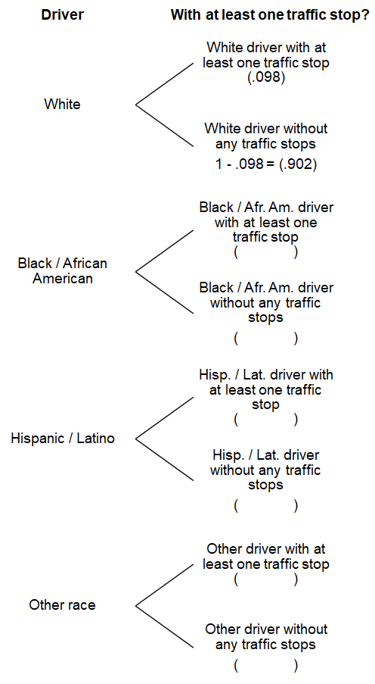
Explain what the numbers in that tree diagram mean. Are drivers of races equally likely to be subject to a traffic stop in a given year? If not, would you characterize the differences as significant?

________________________________________________________________________________________________________________________________________________________________________________________________________________________________________________________________________________________________________________________________________________________________________________________________________________________________________________________________________________________________________________________________________________

Activity 6: Analyzing traffic search data by race
We are going to expand our tree diagram with search data in addition to our traffic stop data. Follow these steps to complete the tree diagram on the next page:

- Begin by copying your probabilities from the previous tree diagram below.

- Use the following table to add the probabilities of a stopped driver being searched.

Race | % of stopped drivers with at least one search
White | 2.3%
Black / African American | 6.3%
Hispanic / Latino | 6.6%
Other | 4.4%

- Calculate the outcome of each row by multiplying the probability of a driver being stopped with the probability of a stopped driver being searched to find the probability that a driver will be searched at least once during the year. You can round each result to three decimal places, but be careful with your decimal places and zeroes!

- Fill in the table after the tree diagram with the probability of a driver of each race experiencing at least one traffic search within a given year.
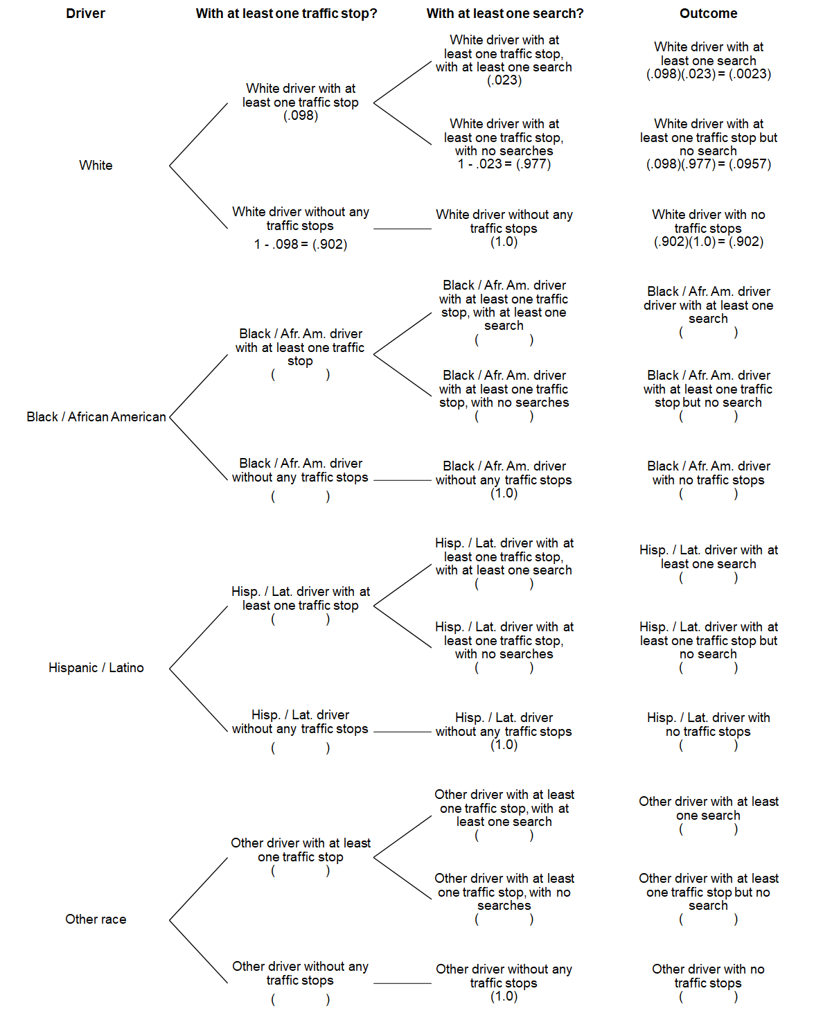

Race | % of drivers with at least one search
White | 0.23%
Black / African American
Hispanic / Latino
Other

Explain what the numbers in this table mean. Are drivers of races equally likely to be subject to a search at a traffic stop in a given year? If not, would you characterize the differences as significant?

________________________________________________________________________________________________________________________________________________________________________________________________________________________________________________________________________________________________________________________________________________________________________________________________________________________________________________________________________________________________________________________________________________________________________________________________________________________________________________________________________________________________________________________________________________________________________________________________________________________________________________________________________________________________________________________________________________________________________________________________________

Activity 8: Exploring King County Data
For this final activity, you will perform random sampling on real King County traffic search data from January 2009 to March 2016. There were 28,105 traffic searches conducted in King County during this timeframe.
You will pick random numbers between 2 and 28,105, look at that row in the King County Traffic Search spreadsheet, and record that search based on the reported race of the driver.
When time is up, calculate the percentage of traffic stops by race by dividing your tallies for each race by the total number of stops you recorded.
Data spreadsheet: tinyurl.com/kingtraffic

White |  | Total:
Black / African American |  | Total:
Hispanic / Latino |  | Total:
Asian |  | Total:
Other |  | Total:

______________ ______________ ______________ ______________ ______________
percent White percent Black / percent Hispanic / percent Asian percent Other
African American Latino

