Create a civilization of your very own by choosing the resources you think will be the most useful. As you choose your resources, consider what will make your civilization successful. After choosing your resources, you will draw a map of your civilization (on the back of this paper) that will be displayed in the classroom.

My civilization is called _________________________________________

Section 1: My civilization is located… (circle one)
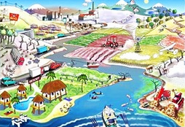
- next to an ocean
- in the mountains
- on an island
- in the rainforest
- next to a river
- in the desert

Section 2: My civilization raises… (circle two)
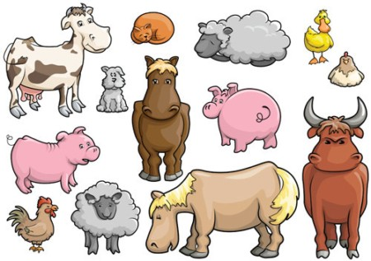
- horses
- chickens
- camels
- llamas
- cows
- cats
- dogs
- fish
Section 3: My civilization grows… (circle two)
- corn
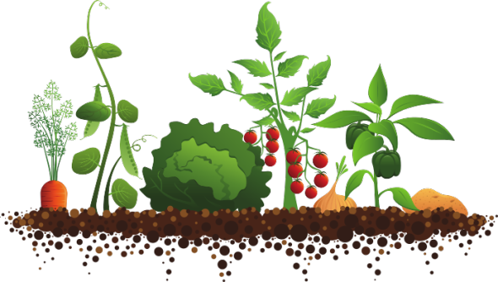
- wheat
- potatoes
- beans
- oranges
- pine trees
- roses

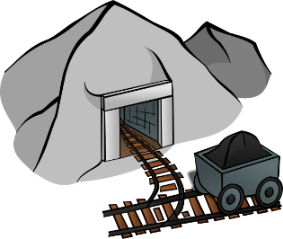
Section 4: My civilization also has… (pick two)
- gold
- iron
- stone
- silk
- bronze

Name:
KEY
Symbol | Section | Choice
 | (2) My civilization raises…
 | (2) My civilization raises…
 | (3) My civilization grows…
 | (3) My civilization grows…
 | (4) My civilization also has…
 | (4) My civilization also has…

