Name: __________________________________________________________ Period: ___________

STEP 1: Take a few minutes to brainstorm a new superhero. Come up with a name for your superhero and one or two superpowers your hero has, and then sketch your superhero in the box below.

Superhero name: ____________________________________________

Superpower #1: _____________________________________________

Superpower #2: _____________________________________________

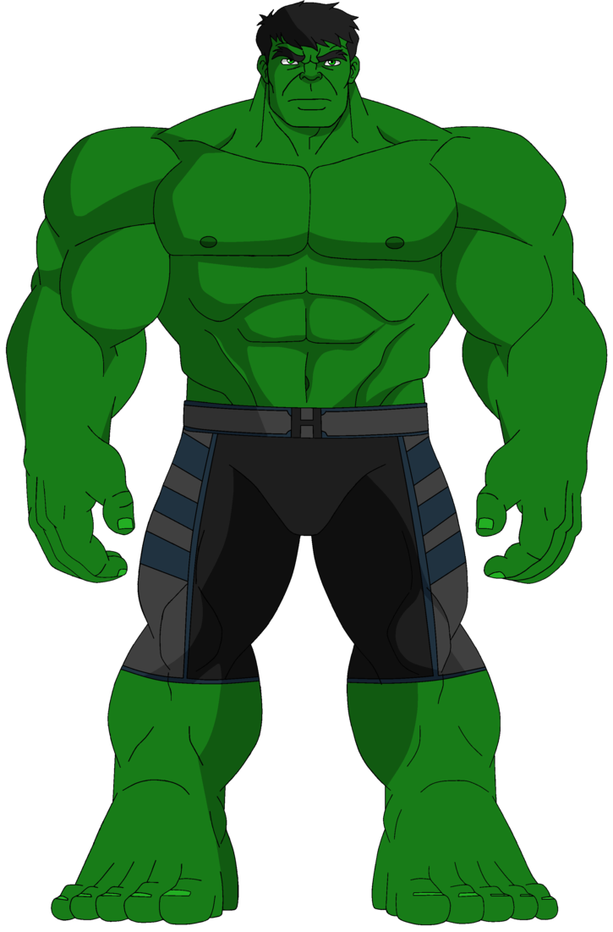
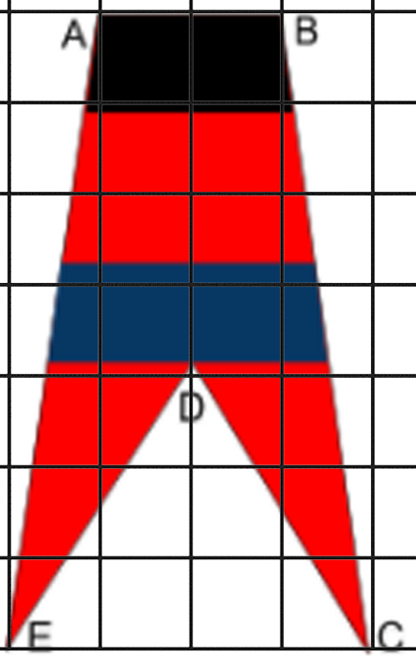
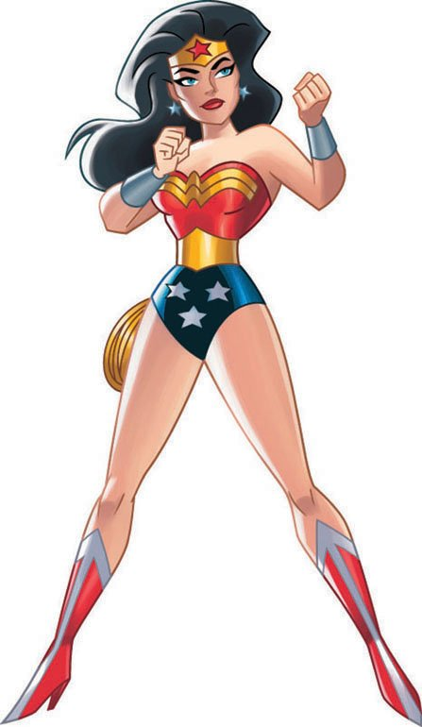
STEP 2: Use abstraction to simplify your superhero design. Look at your design in the box above, and imagine representing that same superhero with a simple geometric shape with five or fewer vertices. You can use color to add some detail, too! Let’s look at a couple of examples:
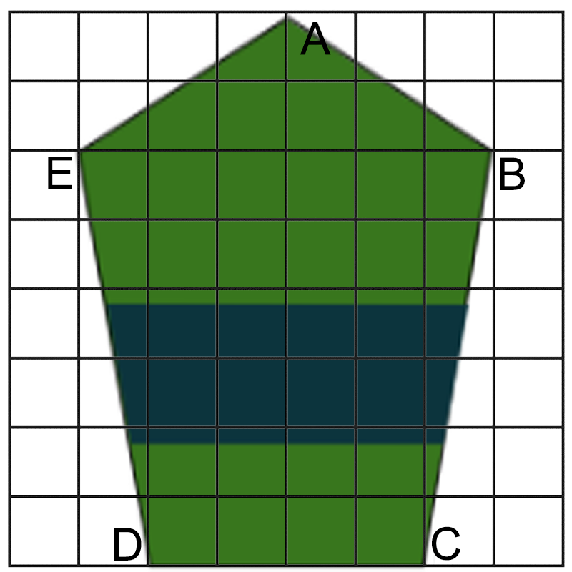

Now it’s your turn. Your shape must use only straight lines (no curves!),
and you can use at most five sides. This means you can use a triangle,
a quadrilateral or a pentagon.

Draw your simplified superhero in the box to the right, and label the vertices
with the letters A through E (or C or D, if you have fewer vertices). Your vertices must land on the intersection of two grid lines. Don’t draw
outside the box!

STEP 3: Choose one of the following three story ideas, then write out your story in a short paragraph using complete sentences. Keep in mind you only have four panels to tell your story in comic form, and don’t forget to use your hero’s superpower(s)!

Idea 1: The first day your superhero discovers their powers. Things get a little out of control!
Idea 2: A supervillain (of your own design) has kidnapped your best friend - how will your superhero free them?
Idea 3: An alien army is invading Tacoma - how will your superhero stop them and save the world?

________________________________________________________________________________________

________________________________________________________________________________________

________________________________________________________________________________________

________________________________________________________________________________________

________________________________________________________________________________________

________________________________________________________________________________________

________________________________________________________________________________________

________________________________________________________________________________________

________________________________________________________________________________________

STEP 4: Use decomposition to break your story down into four panels. Take a look at the template you will be working on, as some panels already have some scenery placed for you. Sketch your comic in the four panels on the next page, making sure you follow these requirements:
- Every panel must include your simplified geometric hero, drawn the same size in each
- Your comic can include captions and word/thought bubbles
- You should use color in the final version, but for now just use pen or pencil to create a quick sketch

STEP 5: Cut out your simplified geometric superhero from the first page and trace it into the first panel of your final comic paper. Make sure the vertices all land on the intersection of two grid lines. Write down the coordinates of each vertex of your hero below. Hint: in the first panel, your x-coordinates will all be negative!

A:______ , ______ B:______ , ______ C:______ , ______ D:______ , ______ E:______ , ______

STEP 6: Use algorithmic thinking to move your superhero into the remaining three panels. For each panel, you will come up with one or more geometric transformation (translation, reflection or rotation) to get your superhero where you want them within the panel.
- You must use at least one reflection OR one rotation in your project
- You must write your steps in the table on the next page, including what transformation(s) you did and the coordinates of each vertex in each panel
- Use the cutout to help you visualize where you want your hero in each panel
- If your superhero only has three or four vertices, you won’t need to fill in all five coordinate pairs

Example: To get my hero from Panel 1 to Panel 2, I... | translated by 20 units in the x-direction (right)  A₂: 5 , 15 B₂: 0 , 18 C₂: -5 , 13 ￼  D₂: -9 , 4 E₂: , ￼
To get my hero from Panel 1 to Panel 2, I... | A₂: ______ , ______ B₂: ______ , ______ C₂: ______ , ______  D₂: ______ , ______ E₂: ______ , ______
To get my hero from Panel 2 to Panel 3, I... | A₃: ______ , ______ B₃: ______ , ______ C₃: ______ , ______  D₃: ______ , ______ E₃: ______ , ______
To get my hero from Panel 3 to Panel 4, I... | A₄: ______ , ______ B₄: ______ , ______ C₄: ______ , ______  D₄: ______ , ______ E₄: ______ , ______

STEP 7: Time to get artistic! Looking back at your story from Step 3 and your panel sketches from Step 4, fill in the remaining details in each panel. These could include:
- Other characters (good guys, bad guys or innocent civilians)
- Scenery (buildings, trees, cars…)
- Word or thought bubbles
- Captions describing what’s happening in each panel

GRADING RUBRIC

Project Component | Point Value
Planning steps completed:  - [Step 1] Superhero name and superpowers listed  - [Step 2] Simplified geometric superhero drawn and cut out  - [Step 3] Story written in short paragraph form  - [Step 4] Each panel sketched with the superhero included in each  - [Step 5] Starting coordinates correctly identified | _______/25  (5 points per step)
Final comic panels completed | _______/12  (3 points per panel)
The steps between each panel listed in the table include:  - correct geometric transformations  - coordinates for the superhero’s vertices | _______/20  (4 points per step)
Neatness/organization/effort  - Handwriting is legible (able to be read)  - Colorful illustrations  - Creative illustrations  - Name and block are written in the correct place | ________/8  (2 points per requirement)
Comments:

Total: _____________/60

SBG Level: __________/4

