Name: ________________________________________________

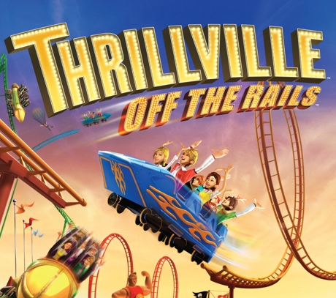
Introduction
You have been asked by a very wealthy investment firm to design a new theme park for your town. The company is awarding a $150 million dollar contract for the successful engineering firm whose design will eventually become THE amusement destination in the country.

There are two deliverables that you must submit in order to win the contract.

- You must make a 3D model of your amusement park.
- You must make a presentation showcasing your attractions.

Requirements
Your 3D model must include
- At least five total attractions (rides, concession stands, games, etc.) with each attraction representing a body system from the choices below:
  - Circulatory
  - Respiratory
  - Nervous
  - Digestive
  - Muscular
  - Skeletal
- A park entrance, ticket booth, walkways and signs for each attraction
- Optional: trees, bushes, fountains, a parking lot, and any other elements found in amusement parks

Your presentation must include:
- The name of your amusement park
- A name for each attraction and a description (at least three sentences) that describes how it relates to the body system and its organs
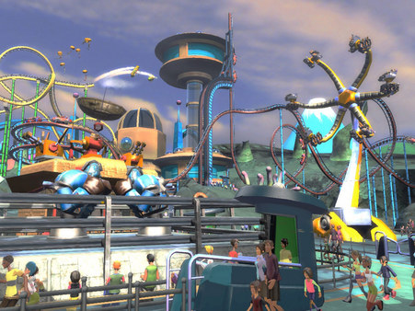
- An argument explaining what makes your amusement park better
than the other proposals. In other words, why should you win?

We will decide which design is best based on design originality, ability to comply with the design deliverables, and overall presentation.

In the space below, jot down some amusement parks you’ve been to and some attractions you’ve seen there:

Brainstorm!

Body System | Ideas | Materials Needed

Where should you start?
- Decide which five body systems you want to incorporate into your amusement park, and what attractions you could use to represent each system. You could design rides, games, shows, etc! Your only limitation is your imagination!
- Research the types of attractions you find at most theme parks. Don’t forget to include things like food stations!
- Play to your strengths! You and your group members all have something unique to bring to the table. While one person may be an expert on the cardiovascular system, another might be an expert on the digestive system!
- Decide who is doing what, and identify what tasks need to be completed in order to complete all sections of the assignment.

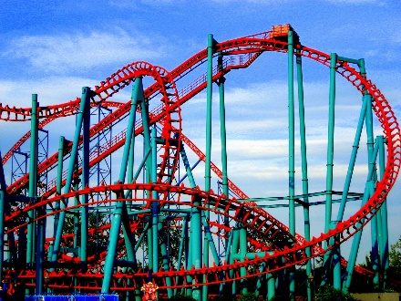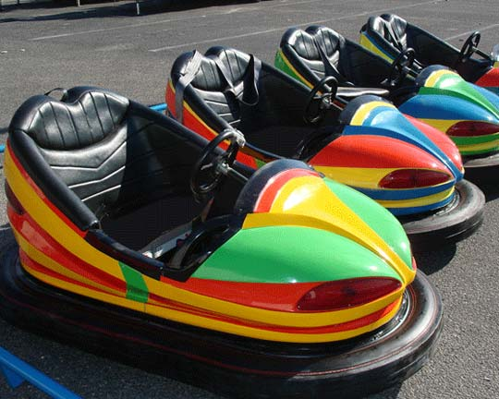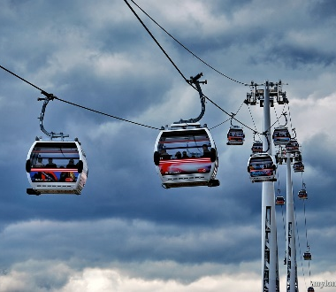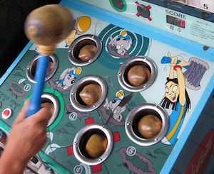

Grading rubric
Element | Developing | Proficient | Advanced
3D Model | - Fewer than five attractions  - Missing some park elements | - At least five attractions  - All required park elements | - More than five attractions  - All required park elements  - At least two optional elements
Presentation | - Missing names or descriptions  - Descriptions are too short  - Poor design  - Argument for being the best is unpersuasive | - Names and descriptions for each attraction  - Good design  - Decent persuasive argument for being the best | - Names and descriptions for each attraction  - Professional design  - Excellent persuasive argument for being the best
Scientific relevance and accuracy | - Little connection to body parts and systems  - Does not demonstrate understanding of all five body systems | - Good connections to body parts and systems  - Demonstrates understanding of all five body systems | - Strong connections to body parts and systems  - Demonstrates deep understanding of all five body systems
Creativity | - Attractions all seem similar  - Names are not related to the attractions | - Each attraction is distinct  - Names are relevant to the attraction | - Each attraction is distinct and seems like fun  - Names are relevant and humorous

