My civilization is called _________________________________________

My civilization is located… (circle one)
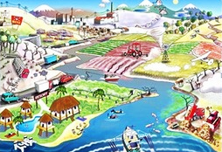
- next to an ocean
- in the mountains
- on an island
- in the rainforest
- next to a river
- in the desert

My civilization raises… (circle two)
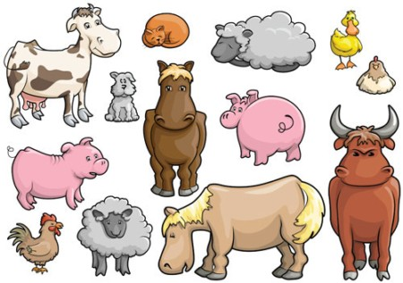
- horses
- chickens
- camels
- llamas
- cows
- cats
- dogs
- fish

My civilization grows… (circle two)
- corn
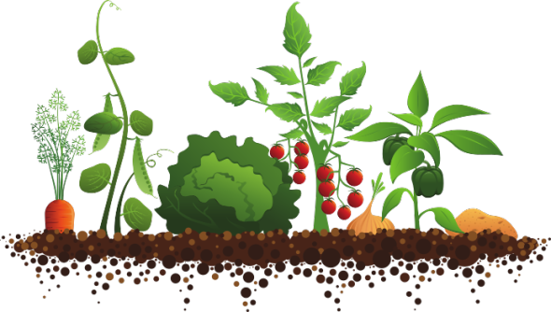
- wheat
- potatoes
- beans
- oranges
- pine trees
- roses

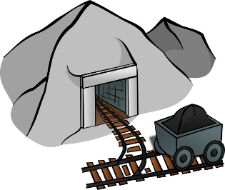
My civilization also has… (pick two)
- gold
- iron
- stone
- silk
- bronze
Each turn, you will fill in one row on the scoresheet below based on the random events, trades and wars that take place during that turn.
 | Encounters with other civilizations  (trades and wars go here) | What happened within my civilization this year?  (random events go here) | Population at the end of the year
Year Zero | None (phew!) | New civilization +100 | 100 citizens
Year One | None (phew!)
Year Two | I traded with ________________________  and received ________________________  in exchange for ______________________
Year Three | I went to war and lost  ___________________ soldiers
Year Four | I traded with ________________________  and received ________________________  in exchange for ______________________
Year Five | I went to war and lost  ___________________ soldiers |  | Final score:

